# Static control flow one time activity and instance control flow multiple times activity. What is the output of the following

Static area instance members

1. From static area, we can’t access instance members directly without reference to object because while executing static area, JVM may not identify instance members.   
   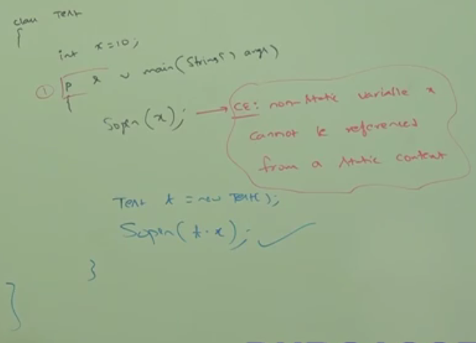

follow “Static Control Flow” and “Instance Control Flow”, you will know the reason why this is an error. ☺

In how many ways we can create an objects in java?

1. **The question may be “In how many ways, we can get object in java”?**
   1. Using **new operator**: new Test();
   2. Using **newInstance():** (Test) Test.class.newInstance();
   3. Using **Factory Method**: Runtime r = Runtime.getRuntime();  
      DateFormat df = DateFormate.getInstance();
   4. Using **clone()**: Test test2 = test1.clone();
   5. Using **Deserialization**:   
       FileInputStream fis = new FileInputStream(“abc.txt”);  
       ObjectInputStream o = new ObjectInputStream(fis);  
       Dog dog = (Dog) o.readObject();

Upto now, we talked about standard way.

* 1. String s = “Hello”;
  2. Integer I = 199;